**Step A – Clone the repository (if not already done)**

git clone https://github.com/SadiaTabas/SafeHer.git

cd SafeHer

**Step B – Set up Git identity (if not already set)**

git config --global user.name "YourGitHubUsername"

git config --global user.email "YourEmail@example.com"

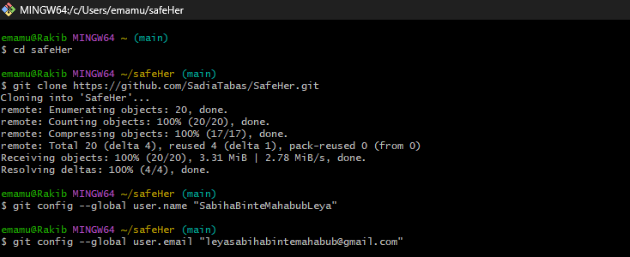

**Step C – Pull the latest main branch**

git checkout main

git pull origin main

Ensures their local copy is up-to-date before doing anything else.

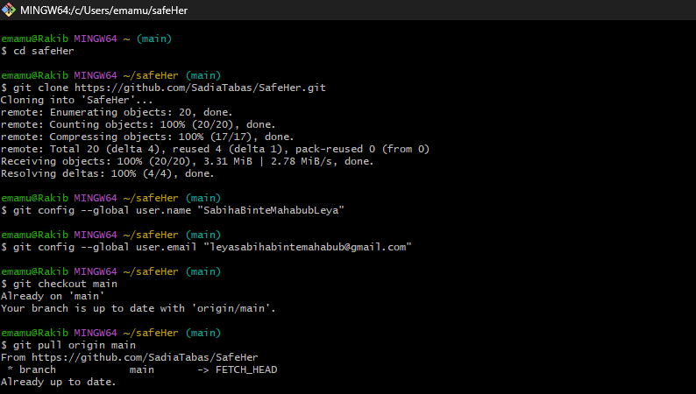

**Step D – Create a new feature branch for assigned work**

git checkout -b feature-branch-name

* Replace feature-branch-name with something descriptive, e.g., update-ui or add-login.
* 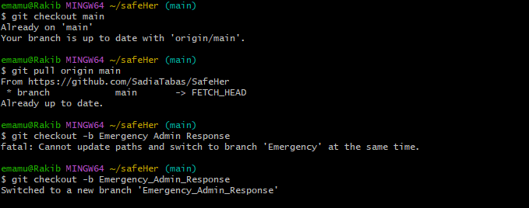
* **Step F – Merge the PR into main (if they have write access)**
* # Option 1: Merge via GitHub website (recommended)
* # 1. Click "Merge pull request" on the PR page
* # 2. Click "Confirm merge"
* # Option 2: Merge locally via command line
* git fetch origin
* git checkout main
* git merge origin/add-doc-file-v3 # or the PR branch name
* git push origin main
* 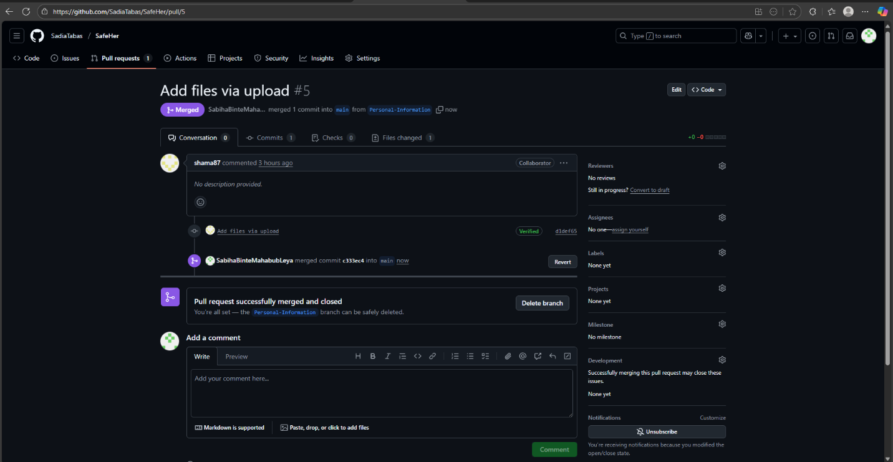

**Step H – Pull the latest main branch after merge**

git checkout main

git pull origin main

Ensures everyone’s local repo has the merged changes.

**Step I – Start new work (repeat workflow)**

git checkout -b new-feature-branch

# Make changes, then:

git add .

git commit -m "Descriptive commit message"

git push origin new-feature-branch

# Create a new PR for review

